
Institute of Distance and Open Learning
Vidya Nagari, Kalina, Santacruz East – 400098

CERTIFICATE
This is to certify that Mr/Ms. of Master in Computer Application (MCA) Semester I of FYMCA with Examination Seat No. & Application No. has completed the specified term work in the subject of

at PCP center of Vidyavardhini's College Of Engineering & Technology, Vasai Road satisfactorily within this institute as laid down by University of Mumbai during the academic year 2025 to 2026.

Subject in-charge External Examination Coordinator - MCA

1

University of Mumbai


Institute of Distance and Open Learning (IDOL)

Subject:
PCP CENTER: DTSS, MALAD

INDEX

SR No. | Experiment Name | Sign.
1. | Client–Server Communication
2. | HTML5 Page Creation
3. | To demonstrate the Fs module file paths and To demonstrate the how to read, write, & close file
4. | Write a PHP program to insert data in table. And also display data on browser with proper tabular format.
5. | Write a PHP program to create a second table as dept and insert the data in it. Display the data from both first and second table.
6. | Create a database called country and create table called city having fields (city name, area, population) using PHP commands. Create an HTML form to get the city data and write a script to insert that data into the table.
7. | Write a program on component life cycle to demonstrate the different phases of it.
8. | Implement a react component that toggles between light and darkmode using useState.
9. | Build a component that changes the document title to "You clicked X times" every time a  counter updates
10. | Build a multilingual app that provide translations through useContext

Experiment 1

AIM
To implement a fundamental client–server model and analyze the Hypertext Transfer Protocol (HTTP) request and response cycle.

OBJECTIVE
  - To establish a local HTTP server using Python within the VS Code environment.
  - To initiate a request from a web browser (Client) to the local server.
  - To inspect and record HTTP transaction metadata, including methods, status codes, and header fields using Browser Developer Tools.

THEORY
The Client–Server model is a distributed application structure that partitions tasks between the provider of a resource or service (the server) and the service requester (the client).
  - HTTP (Hypertext Transfer Protocol): An application-layer protocol used for transmitting hypermedia documents. It follows a request-response pattern.
  - Request Method: Indicates the desired action to be performed (e.g., GET for retrieving data).
  - Status Codes: Issued by the server to indicate the outcome of the request (e.g., 200 OK for success, 404 Not Found for missing resources).
  - Headers: Key-value pairs that provide essential metadata about the request or the response content.

CODE

Resource File (index.html)
Create this file in your VS Code workspace to serve as the requested content. HTML
<!DOCTYPE html>
<html lang="en">
<head>

<meta charset="UTF-8">
<title>Client-Server Experiment</title>
</head>
<body>
<h1>Local Server Connection Successful</h1>
<p>Data transmitted via HTTP/1.1</p>
</body>
</html>

Server Command (VS Code Terminal)
Execute the following command in the integrated terminal to initialize the server: Bash python -m http.server 8000
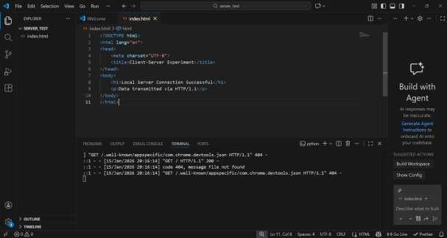

OUTPUT
Upon navigating to http://localhost:8000 in the browser, the following data was captured via the Network Tab in Developer Tools:

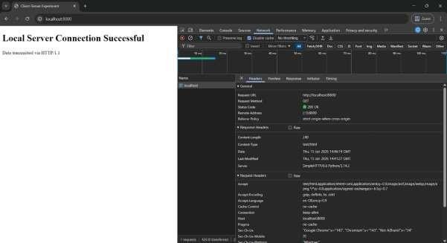

Experiment 2

AIM
To design and develop a structured static webpage using HTML5 semantic elements, multimedia, and user-input forms.

OBJECTIVE
  - To implement a semantic document structure using HTML5 tags.
  - To incorporate common web elements such as headings, paragraphs, images, lists, and hyperlinks.
  - To create a functional contact form with input validation.
  - To apply CSS3 for basic layout styling and modern UI presentation.

THEORY
HTML5 (Hypertext Markup Language) is the standard markup language for documents designed to be displayed in a web browser.
  - Semantic Elements: Tags like <header>, <main>, <section>, and <footer> clearly describe their meaning to both the browser and the developer.
  - Input Types: HTML5 introduces specific attributes like type="email" which provide built-in validation.
  - Multimedia: Images are embedded using the <img> tag or SVG (Scalable Vector Graphics) for high-quality, code-based visuals.
  - Hyperlinks: The <a> (anchor) tag is used to connect different web resources via the href attribute.

CODE
<!DOCTYPE html>
<html lang="en">
<head>
<meta charset="UTF-8">
<title>My Professional Webpage</title>
<style>

body { font-family: sans-serif; line-height: 1.6; max-width: 800px; margin: auto; padding: 20px; }
header { border-bottom: 2px solid #333; padding-bottom: 10px; margin-bottom: 20px; }
.hero-img { width: 100%; height: 200px; background: #f0f0f0; border: 1px solid #ccc;display: flex; align-items: center; justify-content: center; } form { background: #f4f4f4; padding: 20px; border-radius: 8px; }
.input-group { margin-bottom: 15px; } label { display: block; font-weight: bold; } input, textarea { width: 100%; padding: 8px; margin-top: 5px; box-sizing: border-box; } button { background: #007bff; color: white; padding: 10px 15px; border: none; cursor: pointer; }
</style>
</head>
<body>
<header>
<h1>Web Development Portfolio</h1>
</header>

<main>
<section>
<h2>About Me</h2>
<p>This is a static webpage created to demonstrate HTML5 capabilities.</p>
<div class="hero-img"> [Image Placeholder] </div>
</section>

<section>
<h2>Skills & Tools</h2>
<ul>
<li>HTML5 Semantic Tags</li>
<li>CSS3 Styling</li>
<li>Client-Side Validation</li>

</ul>
</section>

<section>
<h2>Contact Us</h2>
<form>
<div class="input-group">
<label>Name:</label>
<input type="text" name="name" required>
</div>
<div class="input-group">
<label>Email:</label>
<input type="email" name="email" required>
</div>
<div class="input-group">
<label>Message:</label>
<textarea name="message" required></textarea>
</div>
<button type="submit">Submit</button>
</form>
</section>
</main>
</body>
</html>

OUTPUT

A. Layout Description
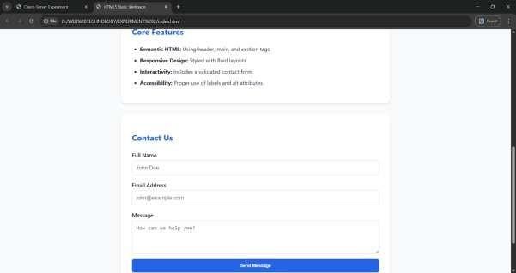
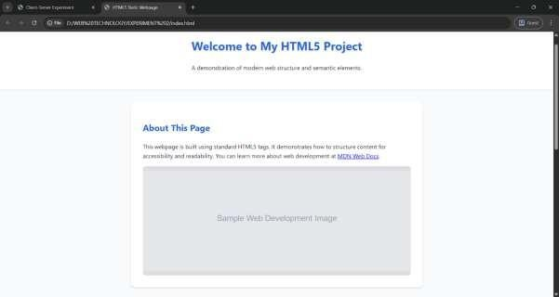
The resulting webpage features a clean, centered layout. The header contains the primary title, followed by an "About" section featuring a placeholder image. The skills are presented in an unordered list, and the bottom section contains a grey-shaded contact form.

Experiment 3

AIM
To demonstrate the use of the Node.js fs (File System) module for handling file paths and performing read, write, and close operations.

OBJECTIVE
  - To understand the difference between synchronous and asynchronous file operations.
  - To implement code that creates (writes), reads, and successfully closes a file.
  - To manage file paths effectively using the Node.js environment.

THEORY
The Node.js File System (fs) module allows you to work with the file system on your computer.
  - fs.writeFile(): Used to asynchronously write data to a file, replacing the file if it already exists.
  - fs.readFile(): Used to read the content of a file. It requires an encoding type (like 'utf8') to return a string instead of a Buffer.
  - fs.open() & fs.close(): Used for more granular control. Opening a file creates a "File Descriptor" (an integer), which must be closed to prevent memory leaks and file locking.
  - File Paths: Node.js uses relative paths (e.g., ./test.txt) or absolute paths to locate files within the workspace.

CODE
Create a file named file_ops.js in VS Code and paste the following code:
// 1. IMPORT: This line tells Node.js to use the File System module const fs = require('fs');

// 2. WRITE: Demonstrates how to write to a file fs.writeFile('message.txt', 'Learning Node.js File System!', (err) =>
{ if (err) throw err; console.log('File has been written!');

// 3. READ: Demonstrates how to read the file fs.readFile('message.txt', 'utf8', (err, data) => { if (err) throw err; console.log('Read from file: '
+ data);

// 4. OPEN/CLOSE: Demonstrates opening and closing a file fs.open('message.txt', 'r', (err, fd) => { if (err) throw err; console.log('File opened successfully.');

// This specifically closes the file fs.close(fd, (err) => { if (err) throw err; console.log('File closed successfully.');
});
});
});
});

OUTPUT

Execution Steps (In VS Code Terminal)
  - Ensure Node.js is installed (node -v).
Run the script: node file_ops.js
  - ​

Observed Console Output

PS D:\WEB TECHNOLOGY\EXPERIMENT 3> node file_ops.js File has been written!
Read from file: Learning Node.js File System! File opened successfully.
File closed successfully.

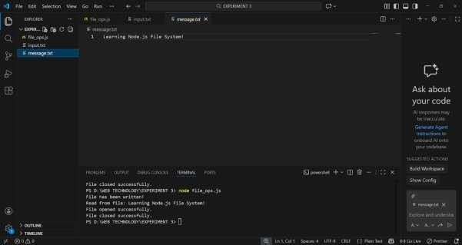

Experiment 4

AIM
To develop a PHP program that inserts user data into a MySQL database table and retrieves the data to display it in a structured tabular format on the browser.

OBJECTIVE
  - To establish a connection between PHP and a MySQL database using the mysqli extension.
  - To implement an HTML form for data entry.
  - To execute SQL INSERT queries to store data.
  - To execute SQL SELECT queries to fetch and render data in an HTML table.

THEORY
PHP interacts with databases (typically MySQL) to create dynamic, data-driven websites.
  - Connection: The mysqli_connect() function initializes a connection between the script and the database server.
  - Data Insertion: Data sent via the POST method from an HTML form is captured in PHP and sent to the database using an INSERT INTO SQL statement.
  - Data Retrieval: The SELECT statement is used to fetch rows. PHP loops through these rows using mysqli_fetch_assoc() to display them inside <table>, <tr>, and <td> tags.

CODE

Database Setup (SQL)
Before running the PHP script, the following table must exist in the database: CREATE DATABASE lab_db;
USE lab_db;

CREATE TABLE students ( id INT AUTO_INCREMENT PRIMARY KEY,
name VARCHAR(50) NOT NULL, email VARCHAR(50) NOT NULL, course VARCHAR(50) NOT NULL

);

PHP Implementation (manage_students.php)
<?php
// 1. Database Configuration
$host = "localhost";
$user = "root";
$pass = "";
$dbname = "lab_db";

$conn = mysqli_connect($host, $user, $pass, $dbname);

if (!$conn) { die("Connection failed: " . mysqli_connect_error());
}

// 2. Handle Data Insertion if (isset($_POST['submit'])) {
$name = $_POST['name'];
$email = $_POST['email'];
$course = $_POST['course'];

$sql = "INSERT INTO students (name, email, course) VALUES ('$name', '$email', '$course')";

if (mysqli_query($conn, $sql)) { echo "<p style='color:green;'>Record added successfully!</p>";
} else { echo "Error: " . $sql . "<br>" . mysqli_error($conn); }

}
?>

<!DOCTYPE html>
<html>
<head>
<title>Student Management</title>
<style> table { width: 100%; border-collapse: collapse; margin-top: 20px; } table, th, td { border: 1px solid black; padding: 8px; text-align: left; } th { background- color: #f2f2f2; } form { margin-bottom: 30px; background: #eee; padding: 15px; width: 300px; } </style>
</head>
<body>

<h2>Insert Student Data</h2>
<form method="POST">
Name: <input type="text" name="name" required><br><br> Email: <input type="email" name="email" required><br><br> Course: <input type="text" name="course" required><br><br>
<input type="submit" name="submit" value="Insert Data">
</form>

<h2>Registered Students</h2>
<table>
<tr>
<th>ID</th>
<th>Name</th>
<th>Email</th>
<th>Course</th>

</tr>
<?php
// 3. Display Data
$result = mysqli_query($conn, "SELECT * FROM students"); while ($row = mysqli_fetch_assoc($result)) { echo "<tr>
<td>{$row['id']}</td>
<td>{$row['name']}</td>
<td>{$row['email']}</td>
<td>{$row['course']}</td>
</tr>";
}
mysqli_close($conn);
?>
</table>
</body>
</html>

OUTPUT
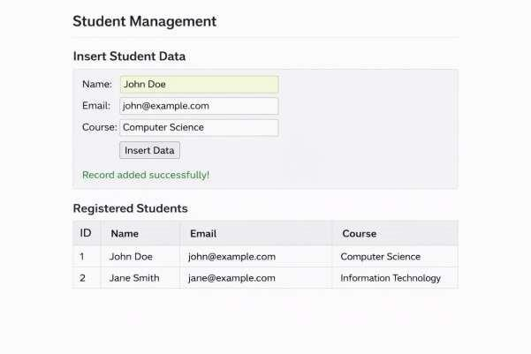
- CONCLUSION
The experiment successfully demonstrated how PHP serves as a bridge between the user interface and the database. By combining HTML forms with SQL queries, we implemented a complete workflow for persistent data storage and real-time display on the browser.

Experiment 5

Write a PHP program to create a second table as dept and insert the data in it. Display the data
- Aim
To write a PHP program to create a second table dept, insert data into it, and display data from both the first and second tables.

Objective
  - To understand table creation using PHP & MySQL

  - To insert and retrieve data from multiple tables

  - To display database records using PHP

Theory
PHP is a server-side scripting language used to interact with databases like MySQL. Using PHP, we can create tables, insert records, and fetch data dynamically using SQL queries.

Code
<?php
$conn = mysqli_connect("localhost", "root", "", "college"); if (!$conn) { die("Connection failed");
}
/* Create dept table */
$sql1 = "CREATE TABLE IF NOT
EXISTS dept ( dept_id INT PRIMARY KEY, dept_name VARCHAR(50)
)";
mysqli_query($conn, $sql1);
/* Insert data */
mysqli_query($conn, "INSERT INTO dept VALUES (1,'CSE'),(2,'IT')");

/* Display data */
$result = mysqli_query($conn, "SELECT * FROM dept"); echo "<h3>Department Table</h3>"; while ($row = mysqli_fetch_assoc($result)) { echo
$row['dept_id']." ".$row['dept_name']."<br>";
}
?>

Output

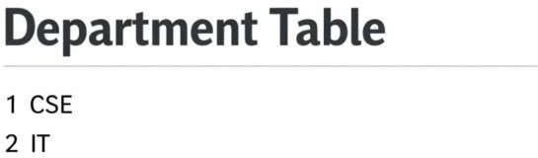

- Conclusion
Thus, we successfully created a second table and displayed data from it using PHP and MySQL.

EXPERIMENT 6

- Aim: To create a database country and a table city, insert city data using an HTML form and PHP.

Objective
  - To create database and table using PHP

  - To collect user input via HTML form

  - To store data in MySQL database

Theory
HTML forms are used to collect data from users, and PHP processes this data to store it into a database using SQL queries.

Code HTML Code
<form method="post">
City Name: <input type="text" name="city"><br> Area: <input type="text" name="area"><br> Population: <input type="text" name="pop"><br>
<input type="submit" name="submit">
</form>

Php Code
<?php
$conn = mysqli_connect("localhost","root","");

mysqli_query($conn,"CREATE DATABASE IF NOT EXISTS country"); mysqli_select_db($conn,"country"); mysqli_query($conn,"CREATE TABLE IF NOT

EXISTS city( cityname VARCHAR(30), area INT, population INT)"); if(isset($_POST['submit'])) {
$c=$_POST['city'];
$a=$_POST['area']; $p=$_POST['pop']; mysqli_query($conn,"INSERT INTO city VALUES('$c',$a,$p)"); echo "Data Inserted Successfully";
}
?>

Output
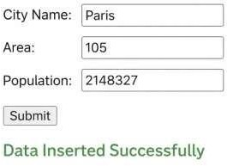

- Conclusion
The program successfully creates a database and inserts city details using PHP and HTML form.

EXPERIMENT 7

- Aim: To demonstrate the different phases of React Component Life Cycle.

Objective
  - To understand lifecycle phases
  - To learn mounting, updating, and unmounting phases

Theory
React component lifecycle consists of:
- Mounting
- Updating
- Unmounting

Lifecycle methods help control component behavior.
- Code import React, { Component } from "react";
class LifeCycleDemo extends Component { constructor() { super(); this.state = { count: 0 };
}
componentDidMount() { console.log("Component Mounted");
}
componentDidUpdate() { console.log("Component Updated");
}
render() { return (
<div>
<h2>Count: {this.state.count}</h2>
<button onClick={() => this.setState({ count: this.state.count + 1 })}> Increment
</button>

</div>
);
}
}
export default LifeCycleDemo;

Output
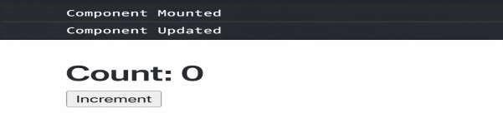

- Conclusion
The program demonstrates various lifecycle phases of a React component.

EXPERIMENT 8

To implement a React component that toggles between Light and Dark mode using useState.

Objective
  - To use React Hooks

  - To toggle UI themes dynamically 3.Theory useState hook allows functional components to manage state in React.
- Code import React, { useState } from "react"; function ThemeToggle() { const [dark, setDark] = useState(false); return ( <div style={{ background: dark ? "black" : "white", color: dark ? "white" : "black", height: "100vh"
}}>
<button onClick={() => setDark(!dark)}> Toggle Mode
</button>
</div> );}
export default ThemeToggle;

Output
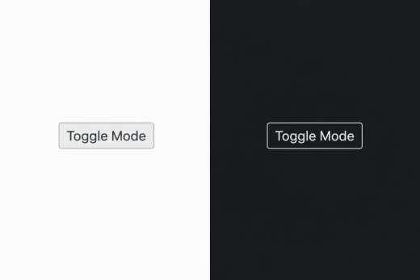
- Conclusion
Light and dark mode toggling is successfully implemented using useState.

EXPERIMENT 9

To change document title dynamically when a counter updates.

Objective
  - To use useEffect hook
  - To modify browser title dynamically
- Theory : useEffect hook performs side effects like updating the Document title.
•
- Code import React, { useState, useEffect } from "react"; function CounterTitle() { const [count, setCount] = useState(0); useEffect(() => { document.title = `You clicked ${count} times`;
}, [count]); return (
<button onClick={() => setCount(count + 1)}> Clicked {count}
</button>
);
}
export default CounterTitle;

Output

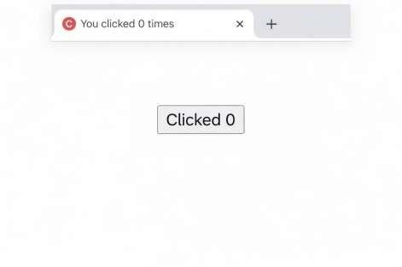

- Conclusion
Document title updates successfully using useEffect.

EXPERIMENT 10

To build a multilingual React application using useContext.

Objective
  - To avoid prop drilling
  - To manage global language state
- Theory: useContext allows sharing data across components without passing props manually.

Code:
import React, { createContext, useContext, useState } from "react"; const LangContext = createContext(); function App() { const [lang, setLang] = useState("en"); return (
<LangContext.Provider value={lang}>
<button onClick={() => setLang("en")}>English</button>
<button onClick={() => setLang("hi")}>Hindi</button>
<Message />
</LangContext.Provider>
);
}
function Message() { const lang = useContext(LangContext); return <h2>{lang === "en" ? "Hello" : "नमस्ते"}</h2>;
}
export default App;

Output
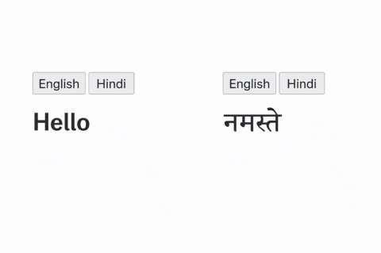
- Conclusion
The multilingual app works successfully using useContext.

